**Presentation Notes:**

1. What are the four functions of a computer program listed on the lesson slide?
   1. Word vs PowerPoint
   2. Word vs Photoshop
   3. Word vs computer games
   4. Word vs imovie
2. Provide an example of a computer input that is not listed on the lesson slide.

One example of a computer input would be a TV remote. A Tv remote is an input device because the buttons on it affects the tv

1. Provide an example of a computer output that is not listed on the lesson slide.

One example of an output would be a computer monitor.

1. Provide another example of how a computer input affects a computer output that is not listed on the lesson slide.

If you press the power button on the monitor, the monitor either switches on or off.

1. Provide an example of how changing the program changes how computer inputs affect computer outputs that is not listed on the lesson slide.

Word vs imovie, as the keys on the keyboard have different functions as the application is open.

1. What are some examples of devices that are not traditional computers but that make use of computer programs?
   1. Industrial robots
   2. Cars which are not self- driving
   3. Kitchen/Appliances
   4. Internet/Social media bots
   5. Toy cars
2. Provide another example of a device that makes use of a computer program that is not listed on the lesson slide.

In the election party’s such as the liberal party use a computer program to post their campaign information.

1. What is another term for a computer program?

Computer program is also known as computer software.

1. What are some ways that computer software is different from computer hardware?

Software uses logic which is flexible and easily changed and hardware uses physical devices which are hard to change.

1. How are computer programs written?

Each line of code represents a command of statement.

1. Why are computer programs composed of many lines of computer code?
2. List some examples of different computer languages.
   1. C/C+ which is used for engineering
   2. Java which is used for web application development
   3. COBOL/SQL which is used for business
   4. Python which is used for simpler codes.
3. List some of the benefits of the Python computer language.
   1. It is a professional language with a large user base
   2. Its good for prototyping or in other words testing smaller programs
   3. Its a good beginner language
   4. It is the language of choice for first year university students
4. Once you finish this course, how could you answer someone who asks you "Do you know how to program in Java?"

Yes, I know how to program simple codes as if you know 1 type of code if it is easy to learn others.

1. Could you use Microsoft Word to write a computer program? Explain.

Yeah but it lacks support to make programming much more easier

1. What does IDE stand for?

Integrated Development environment

1. What are some features of an Integrated Development Environment?
   1. Colour coding of keywords
   2. Indentation and completion control
   3. Error checking
   4. Runtime support and debugging Find problems right when writing code
2. What are some factors to consider when choosing an Integrated Development Environment?
   1. How well its supports you chosen language
   2. It is web based or a download install
   3. Does it cost money
3. What is the name of the IDE that we will be using to create our Python programs?

IDE will be using its own repl.it

It also supports many different programming languages

1. What version of Python will we be using?

Pyhton 3.7

1. Draw a sketch of the Repl interface showing the three work areas (panels)
   1. Label each panel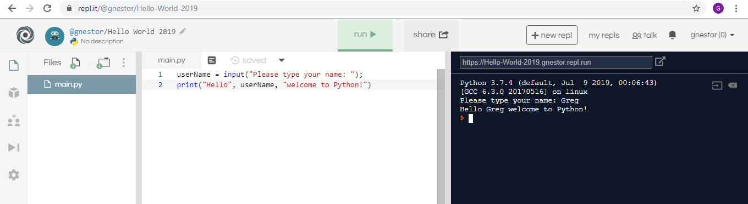
   2. Summarize the function of each panel

Use white area for longer programs

Use black area for simple commands buttons at the top to run your program

**Student Questions:**

1. Create an account for yourself at www.repl.it
   1. Review the "Terms of Service" to verify that you can legally use this service.
   2. Follow the previous discussed guidelines regarding use of personal information
2. List the part of the "Terms of Service" that verifies that you can legally use this service.

You are responsible for maintaining the security of your account, and you are fully responsible for all activities that occur under the account and any other actions taken in connection with your account

1. Explain some of the rights that you give away to Repl.it regarding content you create using their service?

The Service may not be used for hosting content, including images and documents, that knowingly infringes on the intellectual property rights of others, including copyright, trademark and patent infringement, or that includes any obscene or libelous material or other material that violates any applicable law or regulation.

1. Create a new Python repl and call it "Hello World".
2. Copy and paste the following program into the program panel (white area)

userName = input("Please type your name: ");

print("Hello", userName, "welcome to Python!")

1. Run the program to see what it does. (If necessary, fix the quotation marks so it runs properly.)
   1. Explain how the program works.

Program shows up in black area

* 1. Explain how you fixed the program (if necessary)

Put in my name where it said username

1. Try using the console pane (black area) to perform some simple calculations and run some one-line programs.
   1. Summarize some of your calculations.

You cannot do code in the black area

1. Try using the file management pane to add some files and folders to your repl.
   1. Summarize some of your additions.

You can create new folders and files. you cans store folders in the files